Inflammation, part 3

Granulomatous inflammation (inflammationes granulomatosa)
This type of chronic inflammation is defined by the accumulation of activated macrophages that resemble the squamous epithelial cells (epithelioid cells; cellulae epithelioidales). Specific granulation tissue develops with this pathology; it has the specific architecture, without the blood vessels, and in this case, it is called a nodule/granule/tubercle.

The nodule/granule/tubercle is composed of:
- epithelioid cells:
- develop from the macrophages/lymphocytes
- rich in the cytoplasm, with elongated nuclei resembling the foot sole; the cell is elongated, sometimes polygonal; these cells are like the spinous layer cells (in the epithelium)
- prone to coagulative necrosis/caseation (caseificatio/tyrosis)
- Langhans or foreign-body giant cells (fusion of the epithelial cells; cellulae giganteae)
- lymphocytes and plasma cells

Tuberculosis, TB (tuberculosis, Tbc)
This disease is caused by the tubercle bacillus called Mycobacterium tuberculosis; the bovine, avian and human types (typus bovinus, typus avium, and typus humanus) are most pathogenic to animals. The mycobacterium triggers the following types of tissue reactions (with one type being predominant to the others):
- exudative: during the primary infection; the exudate is cellular and exudative, initially with leukocytic infiltration (a non-specific reaction) in response to the tubercle bacilli → within a few hours, the macrophages enter and become predominant; single Langhans giant cells, and lymphocytes → coagulative necrosis and caseation of the exudate (become acidophilic and pale pink), necrosis of the tissue which is infiltrated. Caseous masses may undergo:
  - encapsulation when the tubercle bacilli have been destroyed or have lost pathogenicity
  - calcification
  - malacia when they are no encapsulated or the encapsulation is leaky, which results in cavern (cavities) formation
- proliferative: in this case, the specific tuberculosis granulation tissue/tubercles (tuberculum) develop. Centrally, there are epithelioid cells and Langhans giant cell while peripherally, there are lymphoid cells intermingled with epithelioid cells. The tubercles may coalesce, forming the tubercle aggregates (tuberculum conglomeratum). The tubercles rapidly undergo coagulative necrosis. The caseous masses may undergo:
  - malacia/liquefaction
  - condensation/calcification (if incomplete, live tubercle bacilli may survive)
  - hypertrophy with connective tissue/fibrosis

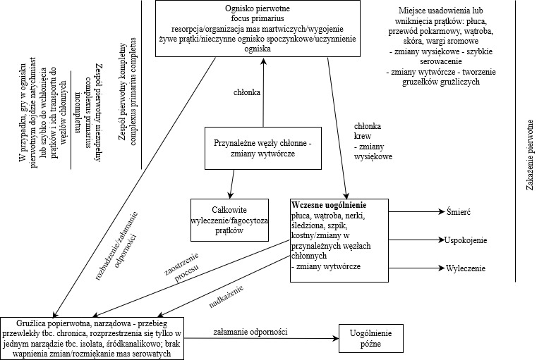

W przypadku gdy w ognisku pierwotnym… | If the tubercle bacilli are immediately or rapidly absorbed in the primary focus they are transported to the lymph nodes
Zespół pierwotny niezupełny | Primary incomplete complex (complexus primaries incompletus)
Zespół pierwotny kompletny | Primary complete complex (complexus primaries completus)
Ognisko pierwotne… resorpcja… | Primary focus (focus primarius)  Resorption/organization of necrotic masses/healing  Live tubercle bacilli/inactive quiescent focus/activation of the focus
Chłonka | Chyle
Przynależne węzły chłonne – zmiany wytwórcze | Local lymph nodes – proliferative lesions
Całkowite wyleczenie/fagocytoza prątków | Complete healing/phagocytosis of the tubercle bacilli
Chłonka  Krew - zmiany wysiękowe | Chyle  Blood – exudative lesions
Wczesne uogólnienie, płuca, wątroba… | Early generalization  Lungs, liver, kidneys, spleen, bone marrow/lesions in the local lymph nodes – proliferative lesions
Śmierć | Death
Uspokojenie | Dormancy
Wyleczenie | Healing
Zaostrzenie procesu | Exacerbation
Nadkażenie | Superinfection
Gruźlica popierwotna, narządowa – przebieg… | Post-primary tuberculosis, organ TB – chronic course of tuberculosis, affect only one organ – isolated TB, intratubular; without calcification/malacia of caseous masses
Załamanie odporności | Breakthrough infection
Uogólnienie późne | Late generalization
Miejsce usadowienia lub wniknięcia prątków… | Locations or entrance site for the tubercle bacilli: lungs, gastrointestinal tract, liver, skin, labia  - exudative lesion – rapid caseation  - proliferative lesions – development of tubercles
Zakażenie pierwotne | Primary infection

Pulmonary tuberculosis – acute miliary tuberculosis (tuberculosis miliaris acuta pulmonum)
Grossly: multiple small, hard, and whitish tubercles are found in the lung parenchyma.
A Ziehl-Neelsen staining procedure is used to detect and confirm the presence of tubercle bacilli. The bacteria stain red.

Lymph node tuberculosis (tuberculosis lymphonodi)
- exudative type: the exudate rapidly undergoes caseation. Caseous masses are arranged radially – radial caseation of the lymph node, mainly in the cortex (caseificatio radiata lymphonodi). In between, some bands or foci of the regular parenchyma are found. The blood vessels are noticeably dilated and filled with blood. With time, caseous masses calcify (tbc. caseificata lymphonodi).
- proliferative type: small tubercles coalesce with time and form larger nodules (tuberculum conglomeratum), and finally, a homogenous cellular mass develops and occupies the whole lymph node.

Splenic tuberculosis (tuberculosis lienis)
This disease presents with nodules composed of specific and non-specific granulation tissue. The TB nodules caused by the bovine type of the TB bacilli caseate and calcify early, whereas, during the infection caused by the avian TB type, they are lardaceous and are not prone to caseation or calcification. The development of connective tissue is quite profuse, and the tissue – while shrinking – causes navel-shaped cavities in the central part of the nodules (gross presentation). The TB nodules vary in size (tbc. miliaris/tbc. nodosa) or infiltration with large amounts of the TB granulation cells may develop, which results in a tubercular enlargement of the organ (splenomegalia tuberculosa).

Glanders (malleosis)
An infectious and usually chronic disease of the odd-toed ungulates caused by the bacterium Burkholderia mallei; the disease can be zoonotic (in humans) and affect carnivores (in cats). The pathology presents as proliferative-exudative-necrotic inflammation, with the proliferative or exudative component being predominant.
Grossly, the lesions are polymorphous: nodes, nodules, abscesses, scars, and liquid exudate. The lesions are situated in the nasopharynx, lymph nodes, intestines, lungs, and skin. The pathogenesis of glanders is similar to tuberculosis: there is a primary focus of the disease, a primary complex → healing, early generalization. The glanders nodules may calcify.

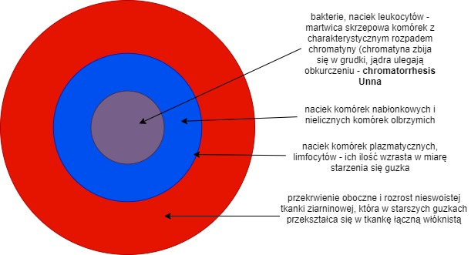

Bakterie, naciek limfocytów… | Bacteria, infiltration with the leukocytes – coagulative necrosis of the cells with a specific degradation of chromatin (it lumps by forming papules, and the nuclei shrink) – chromatorrhesis Unna
Naciek komórek nabłonkowych… | Infiltration with the epithelial cells and few giant cells
Naciek komórek plazmatycznych… | Infiltration with the plasma cells and lymphocytes – their number increases when the nodules ages
Przekrwienie oboczne… | Peripheral oedema and hypertrophy of the non-specific granulation tissue that transforms into the fibrous connective tissue in older nodules

Actinomycosis (actinomycosis)
A chronic granulomatous inflammation caused by Actinomyces bovis and presents with proliferative and exudative (purulent) processes. The lesions are polymorphic: actinomycotic nodules, disseminated nodular actinomycosis, actinomycotic sclerosis, large nodules, fungoid masses, abscesses, erosions and ulcerations.
Actinomycosis primarily affects the bone of the skull (maxilla, mandibula) and then spreads onto surrounding soft tissues. If the pathogen is not killed and the lesions do not become fibrotic, the disease further spreads in the body, mainly via the phagocytic cells and leukocytes. New actinomycotic nodules develop, with accompanying diffuse hypertrophy of the connective tissue.

Microscopic presentation:
Actinomycetes are in the central part of the nodules and form rosette-like structures that resemble fungal threads with club-like ends. The “actinomycotic bodies” are surrounded and filled with a neutrophilic infiltrate (purulent exudate); sometimes, eosinophils are found. Grossly, it looks line small abscesses. The most outer layer consists of the specific granulation tissue composed of the epithelioid cells, histiocytes, plasma cells, single giant cells, and blood vessels as well as the connective tissue that, with time and ageing of the lesions, becomes the fibrinous connective tissue with embedded eosinophils in lower or higher numbers.
The Splendore-Hoeppli phenomenon: the bacteria are embedded in amorphous and acidophilic material, which forms the antigen-antibody complexes.

Botryomycosis (botriomycosis); suppurative granuloma (granuloma pyogenes)
The disease is also called bacterial pseudomycosis. It is chronic granulomatous inflammation with the proliferative and exudative (suppurative) nature and the noticeable predominance of a proliferative component. The disease is caused by Botryococcus ascoformans; it also presents as wound infection (horses: a stump of the spermatic cord, prosternum, beneath the horse harness, and in the pastern region) with hard nodules that vary in size, are yellow-red or brown, and have small abscesses; with time, they suppurate and develop fistulae. The local lymph nodes or even the internal organs (liver and lungs) may be affected if the infection spreads via the lymphatic vessels. This type of inflammation is accompanied by the Splendore-Hoeppli phenomenon.

Microscopic presentation:
Bacterial clusters are situated in the centre of the nodule (botryomycotic follicles), with the size of a sand granule, and resembling raspberries or mulberries. The nodules are surrounded by the infiltration of neutrophils that after their degradation transforms into a suppurative mass. The most outer layer consists of the inflammatory granulation tissue composed of the epithelioid cells (single giant cells), leukocytes, neutrophils, lymphocytes and plasma cells. The whole structure is surrounded by the connective tissue that becomes fibrotic with time. The nodules do not calcify.

Paratuberculosis (paratuberculosis); Johne’s disease, infectious bovine proliferative catarrhal enteritis
This is a proliferative inflammation of the intestines caused by Mycobacterium paratuberculosis.
Gross presentation: the intestinal mucosa (mainly in the jejunum and ileum) is thickened (2 to 20 times), crosswise and lengthwise folded, which makes it resemble the ganglia of the cerebral cortex. The mucosa is pale, white-yellow, with petechiae and covered with grey-green mucous exudate (like sprinkled with parmesan cheese).

Microscopic presentation: thickening of the mucosa, which results from infiltration of the specific granulation cells – the epithelioid cells (contain phagocytized mycobacteria), lymphocytes, single Langhans giant cells, eosinophils, neutrophils and plasma cells. Growing granulation tissue compresses the glands and makes them undergo atrophy.

For diagnostic purposes, Zhiel-Neelsen staining can be performed to detect the presence of phagocytized mycobacteria in the tissue samples.

Colibacillosis (coligranulomatosis)
A chronic proliferative inflammation of chickens, turkeys and geese caused by the mucous strains of E. coli, accompanied by the other bacteria (Pseudomonas, Proteus, Salmonella). The disease presents with multinodular granulomas that resemble the proliferative type of tuberculosis. The nodules are situated mainly in the gastrointestinal tract, liver, spleen and lungs, are whitish, with the size of a millet grain or a fist; the cross-section has a layered arrangement like the growth rings); with malacia in the centre (necrosis) and is prone to cavity formation; surrounded by the granulation tissue.

A young nodule is composed of:
- epithelioid cells
- lymphocytes
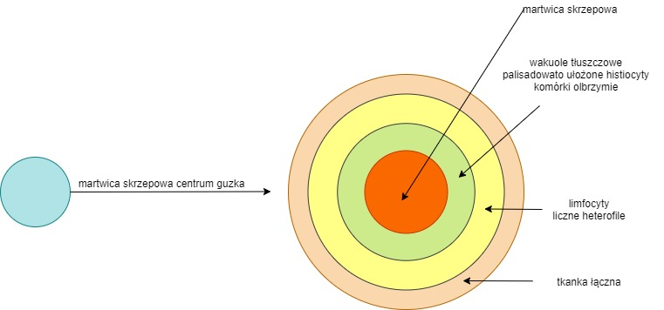
- heterophils.

Martwica skrzepowa centrum guzka | Central coagulative necrosis in the nodule
Martwica skrzepowa | coagulative necrosis
Wakuole tłuszczowe… | Lipid vacuoles  histiocytes are arranged palisade-like  giant cells
Limfocyty  Liczne heterofile | Lymphocytes  Numerous heterophils
Tkanka łączna | Connective tissue

